Not for reproduction 93/WG2(Secretary)..
Original: English October 2004

INTERNATIONAL E LECTROTECHNICAL COMMISSION

Draft minutes of the TC93 WG2 meeting
Piscataway, USA 5-6 October, 2004

1. Opening of the meeting

  - Introduction – Meeting called to order
1.2 Review group membership -- Done

- Approval of the agenda: 93/WG2 – Agenda was approved
- Minutes of the last meeting – Action items from last meeting were reviewed and closed. 2003 minutes were approved.

3. Summary of last year group activity

  - Report of group activity: -- A report of last year group activity was presented
3.2 Items in Dual Logo program – Only one DL in work (ALF). No action needed at this time

4. WG2 Plans and Priorities

4.1 Publication plan items (due dates review) – no changes are needed on official schedule
  - Review of TC93 program of work (items for WG2). – Project “Validation of ALF TR” belongs to WG 5
  - Review and discussion of TC93 shopping list
    - IEEE Std 1076.6™-2004 – Synthesis subset for VHDL – Action Alex:
Propose as DL during TC meeting
    - ```````` IEEE Std 1364.1™-2002 – Synthesis subset for Verilog® -- Action Alex: Propose as DL during TC meeting
    - IEEE SystemVerilog Group
      - P1800 SystemVerilog – To be monitored by IEC- IEEE/(DASC) liaison procedures, WG2 will report any interoperability issues/concerns to WG1, review any new reports form WG1 concerning P1800. THE GOAL IS TO SUBMITT IEEE 1800 AS DL (ASAP). Estimated time for IEEE completion is Fall 2005. See also presentation from Accelera.
Action Dennis: Recommend a liaison to the CAG, explain the impact of SA to WG2
      - P1364 Verilog® (NEW PAR) – Errata version, non controversial maintenance of the IEC Verilog™ - should replace Verilog™ 2001 and be circulated as DL when done in IEEE
    - IEEE P1666 – System C – No approved PAR (expected mid Nov. 2004).
Last draft available at www.systemc.org. New release to be expected soon.
LRM defines the core language only, it does not include code, there is some open source that is needed to make system C run. However, other software might be needed to make the system C complete (see Figure 1).
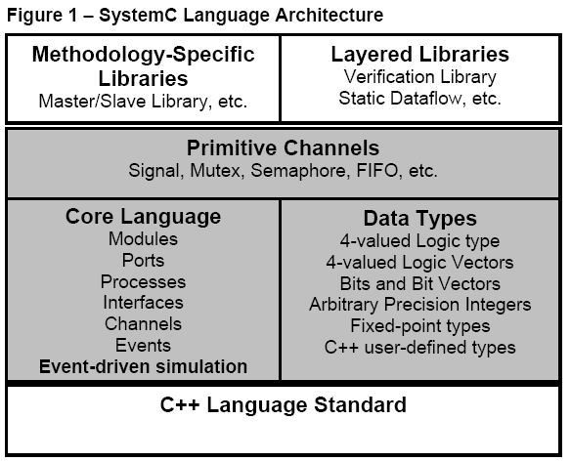
The items in the shaded areas were donated. White low area (C++) does not have to be donated (it is a separate standard), the concern was about the items in the white area on top. Group will continue to monitor the status of the completeness of the System C.
    - IEEE 1076.1 – Action Alex (inherited from Ron): Contact chair and check the status of the re-affirmation
    - IEEE XXXX PSL – No action required yet
    - IEEE XXXX e™-Language – Action Alex: Check with group chair on the production of special chapter including the general (abstract) semantic of assertions
    - Other

- Work Item Status Discussions

  - Dual logo Items -- Alf project is advancing as planned
  - Active projects items – One active project only, no action needed.

- Maintenance of IEC TC93 WG2 Standards

  - Dual logo
    - Current proposed procedures – The current procedures were presented and analyzed.
      - First concern was that the IEC final balloting in will take longer (5 months listed) then the IEEE
one. In reality only 60 days might be needed in the IEC.
      - Second concern was that the IEC loop of CDV will
run slower then the IEEE one, and it will require the production of intermediary versions for review. This is true and un avoidable.
      - Third, some members thought that the actual
DASC situation does not provide for the creation of intermediary drafts for review. Alex mentioned that the quality of a standard is produced during review, and that process should be improved in DASC to avoid situations where documentation starts late.
  - Cases where the feeder does not exist anymore – Those cases
will be considered as the situation arrives.

- The future EDA standards

  - Activities in ASIA – PACIFIC – were presented by Mr. Yoshio
Okamura (see attachment)
  - Activities in Accellera were presented by Dennis Brophy (see
attachment)
(all TC was invited to attend this presentation)
Questions were raised about the joint oversight of SystemVerilog
group regarding DASC relationship. Answers: DASC does not have anything to say, or control any of the SystemVerilog group, even if the positions on the “Joint Supervision Group” are tighten to the DASC positions, and not to the individuals. The control of the SystemVerilog work is not symmetrical as presented.
  - Updates form IEEE DASC – Alex presented a “colorful” email regarding DASC, its power to decide and consider the technical progress, common concerns shared by more then one standard effort, the consequences of introducing more non-technical interest to sort technical problems, in general a less optimistic view of the actual situation (see attachment). Besides what was presented by Accelera, the status of other groups was available but not presented (see attachments).

  - The new SAE AADL – Two documents regarding a new rigorous (meaning addressing also the requirements of critical systems) system “Architecture Analysis” language developed as a standard by the SAE were presented (see attachments). Group will decide if there is a need for a TC93/WG2 liaison to the SAE group.

- WG2 Report to the Plenary -- A brief report will be presented

- .Additional business
9.1 DASC as a feeder organization – Ron Waxman – This item was originally added to the agenda, but discussed during the TC Management Meeting
- Date and place of next meeting
Future WG2 Face meeting candidates
Jan 2005 – Japan
March 2005 – Frankfurt, Germany (DATE)
At DAC in July 2005
With TC Plenary in September 2005
,,,2006 London UK
…2007 Bucharest Romania
…2008 India

- Closure of the meeting – meeting adjourned

Respectfully Submitted
Alex Zamfirescu

